**CIS-481: Introduction to Information Security**

**InfoSec Chapter Exercise #5 - Option A**

**Team: Seven**

**Participants: Jackson Dillingham, Matt Jackson, Hilton Siaffa, Tabor Payne, and Emily Wantland**

**Logistics**

1. Get together with other students on your assigned team in person and virtually.
2. Review the two options available and decide on only one to pursue as a team.
3. Discuss and complete this assignment in a collaborative manner. Don’t just assign different problems to each teammate as that defeats the purpose of team-based learning.
4. Choose a scribe to prepare a final document to submit via Blackboard for grading, changing the file name provided to denote the number of your assigned **Team**.

**Problem 1**

Complete Exercise 1 from pp. 320 of your text with the following changes. Switch L47’s hardware failure has an expected rate of occurrence of once every 5 years and when that happens it is 100% failure of the device. The SNMP buffer overflow has an expected rate of occurrence of once every five years but only 50% of those attacks are successful. When it is successful, 100% of the asset would be lost or compromised. For server WebSrv6, the invalid Unicode vulnerability is attempted to be exploited once a year but only 10% of those attacks are successful. When those attacks succeed, existing controls keep the loss down to 25% of the asset. For the MGMT45 console, the estimated rate of occurrence of unlogged misuse by the operators is once every 10 years but when it happens, there are no controls in place to reduce the impact, so 100% loss of the asset is likely.

Perform the risk calculations (as shown on p. 287) and determine in what order each of the threat vulnerabilities should be addressed based on the relative risk. Show your work. *(15 points)*

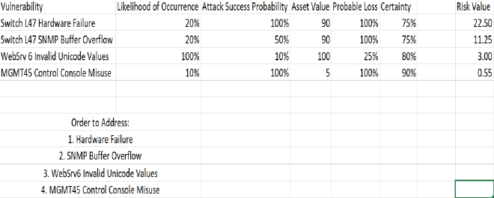

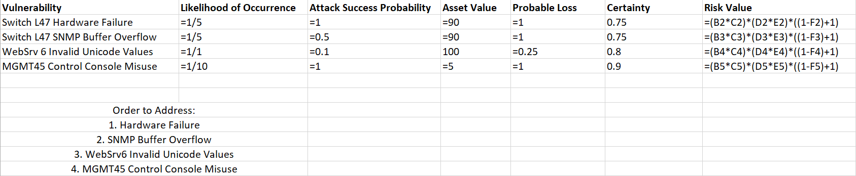

**Problem 2**

Complete Exercise 3 from p. 320 of your text. You should create a worksheet using Microsoft Excel to support your calculations, then paste an image of the table with column headings and rows just below. Attach the Excel workbook when submitting this document file for grading. *(15 points)*

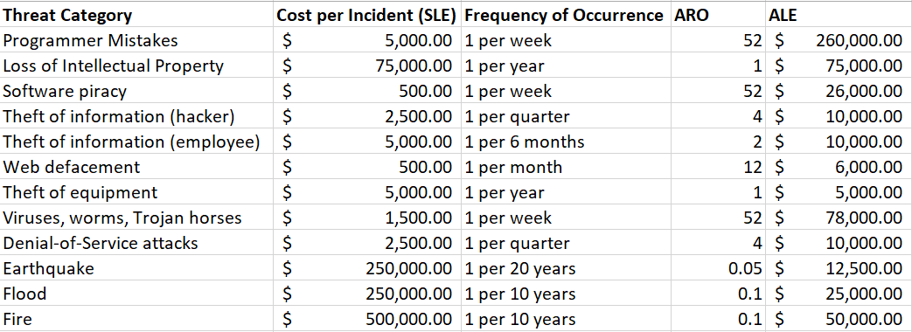

**Problem 3**

Complete Exercise 5 from p. 321 of your text. You should create a worksheet using Microsoft Excel to support your calculations, then paste an image of the table with column headings and rows just below. Attach the Excel workbook when submitting this document file for grading. Don’t forget to address all of the questions at the end of Exercise 5. *(20 points)*

